4.5.2 Questions

Q4-1. List three techniques of digital-to-digital conversion.

Answer: The three different techniques described in this chapter are line coding, block cod ing, and scrambling.

Q4-2. Distinguish between a signal element and a data element.

Answer: A data element is the smallest entity that can represent a piece of information (a bit). A signal element is the shortest unit of a digital signal. Data elements are what we need to send; signal elements are what we can send. Data elements are being carried; signal elements are the carriers.

Q4-3. Distinguish between data rate and signal rate.

Answer: The data rate defines the number of data elements (bits) sent in 1s. The unit is bits per second (bps). The signal rate is the number of signal elements sent in 1s. The unit is the baud.

Q4-4. Define baseline wandering and its effect on digital transmission.

Answer: In decoding a digital signal, the incoming signal power is evaluated against the baseline (a running average of the received signal power). A long string of 0s or 1s can cause baseline wandering (a drift in the baseline) and make it difficult for the receiver to decode correctly.

Q4-5. Define a DC component and its effect on digital transmission.

Answer: When the voltage level in a digital signal is constant for a while, the spectrum cre ates very low frequencies, called DC components, that present problems for a sys tem that cannot pass low frequencies.

Q4-6. Define the characteristics of a self-synchronizing signal.

Answer: A self-synchronizing digital signal includes timing information in the data being transmitted. This can be achieved if there are transitions in the signal that alert the receiver to the beginning, middle, or end of the pulse.

Q4-7. List five line coding schemes discussed in this book.

Answer: In this chapter, we introduced unipolar, polar, bipolar, multilevel, and multitran sition coding.

Q4-8. Define block coding and give its purpose.

Answer: Block coding provides redundancy to ensure synchronization and to provide inher ent error detecting. In general, block coding changes a block of m bits into a block of n bits, where n is larger than m.

Q4-9. Define scrambling and give its purpose.

Answer: Scrambling, as discussed in this chapter, is a technique that substitutes long zero level pulses with a combination of other levels without increasing the number of bits

Q4-10. Compare and contrast PCM and DM.

Answer: Both PCM and DM use sampling to convert an analog signal to a digital signal. PCM finds the value of the signal amplitude for each sample; DM finds the change between two consecutive samples.

Q4-11. What are the differences between parallel and serial transmission?

Answer: In parallel transmission we send data several bits at a time. In serial transmission we send data one bit at a time.

Q4-12. List three different techniques in serial transmission and explain the differences.

Answer: We mentioned synchronous, asynchronous, and isochronous. In both synchro nous and asynchronous transmissions, a bit stream is divided into independent frames. In synchronous transmission, the bytes inside each frame are synchro nized; in asynchronous transmission, the bytes inside each frame are also indepen dent. In isochronous transmission, there is no independency at all. All bits in the whole stream must be synchronized.

4.5.3 Problems

P4-1. Calculate the value of the signal rate for each case in Figure 4.2 if the data rate is 1 Mbps and c = 1/2.

Answer: We use the formula s = c × N × (1/r) for each case.

We let c = 1/2.

a. r = 1 → s = (1/2) × (1 Mbps) × 1/1

b. r = 1/2 = 500 kbaud → s = (1/2) × (1 Mbps) × 1/(1/2) = 1 Mbaud

c. r = 2 →s = (1/2) × (1 Mbps) × 1/2 = 250 Kbaud

d. r = 4/3 → s = (1/2) × (1 Mbps) × 1/(4/3) = 375 Kbaud

P4-2. In a digital transmission, the sender clock is 0.2 percent faster than the receiver clock. How many extra bits per second does the sender send if the data rate is 1 Mbps?

Answer: The number of bits is calculated as (0.2 /100) × (1 Mbps) = 2000 bits

P4-3. Draw the graph of the NRZ-L scheme using each of the following data streams, assuming that the last signal level has been positive. From the graphs, guess the bandwidth for this scheme using the average number of change in the signal level. Compare your guess with the corresponding entry in Table 4.1.

a. 00000000 b. 11111111 c. 01010101 d. 00110011

Answer:

P4-4. Repeat Problem P4-3 for the NRZ-I scheme.

Answer:

P4-5. Repeat Problem P4-3 for the Manchester scheme.

Answer:

P4-6.Repeat Problem P4-3 for the differential Manchester scheme.

Answer:

P4-7. Repeat Problem P4-3 for the 2B1Q scheme, but use the following data streams.

a. 0000000000000000

b. 1111111111111111

c. 0101010101010101

d. 0011001100110011

Answer:

P4-8. Repeat Problem P4-3 for the MLT-3 scheme, but use the following data streams.

a. 00000000 b. 11111111 c. 01010101 d. 00011000

Answer:

P4-9. Find the 8-bit data stream for each case depicted in Figure 4.36. Figure 4.36 Problem P4-9 b. differential Manchester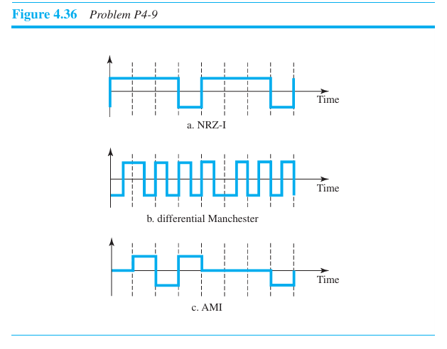

Answer:

P4-10. An NRZ-I signal has a data rate of 100 Kbps. Using Figure 4.6, calculate the value of the normalized energy (P) for frequencies at 0 Hz, 50 KHz, and 100 KHz.

Answer:



Answer:

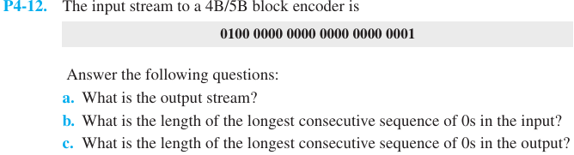

Answer:

P4-13. How many invalid (unused) code sequences can we have in 5B/6B encoding? How many in 3B/4B encoding?

Answer:

P4-14. What is the result of scrambling the sequence 11100000000000 using each of the following scrambling techniques? Assume that the last non-zero signal level has been positive.

1. B8ZS b. HDB3 (The number of nonzero pulses is odd after the last substitution.)

Answer:

P4-15. What is the Nyquist sampling rate for each of the following signals?

a. A low-pass signal with bandwidth of 200 KHz?

b. A band-pass signal with bandwidth of 200 KHz if the lowest frequency is 100 KHz?

Answer:

P4-16. We have sampled a low-pass signal with a bandwidth of 200 KHz using 1024 levels of quantization.

a. Calculate the bit rate of the digitized signal.

b. Calculate the SNRdB for this signal.

c. Calculate the PCM bandwidth of this signal.

Answer:

P4-17. What is the maximum data rate of a channel with a bandwidth of 200 KHz if we use four levels of digital signaling.

Answer:

P4-18. An analog signal has a bandwidth of 20 KHz. If we sample this signal and send it through a 30 Kbps channel, what is the SNRdB?

Answer:

P4-19. We have a baseband channel with a 1-MHz bandwidth. What is the data rate for this channel if we use each of the following line coding schemes?

1. NRZ-L b. Manchester c. MLT-3 d. 2B1Q

Answer:

P4-20. We want to transmit 1000 characters with each character encoded as 8 bits.

a. Find the number of transmitted bits for synchronous transmission.

b. Find the number of transmitted bits for asynchronous transmission.

c. Find the redundancy percent in each case. CHAPTER 4 DIGITAL TRANSMISSION 0100 0000 0000 0000 0000 0001

Answer: